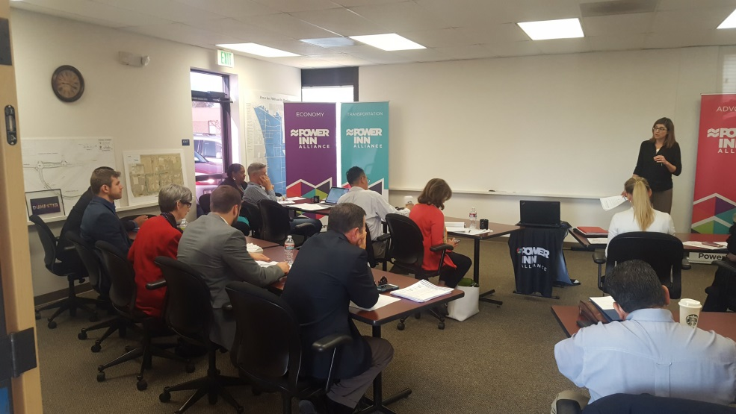

Property Business Improvement Districts (PBIDs) Convening

April 2017 Jobs/Economic Development VISTA

On March 30th, the Sacramento Promise Zone’s Small Business Development partners convened 6 PBIDs: Stockton Blvd Partnership, Greater Broadway Partnership, Power Inn Alliance, Mack Road Partnership, Franklin Blvd Business Association, and The River District. More than 20 people representing non-profits, government agencies, and educational institutions around Sacramento attended this convening.
During the event, a representative from the Sacramento Promise Zone, Celia Yniguez discussed the importance of partnerships between PBIDs and non-profits by highlighting California Capital Financial Development Corporation’s EDA grant as an example. After, there was a mini exercise engaging the PBIDs to understand their needs and characteristics (i.e., who are BIA’s, CDC’s, PBIDs, etc.).
Lastly, two small business development initiatives were discussed and introduced to the PBID executives: Slingshot and Rapid Acceleration, Innovation, and Leadership in Sacramento (RAILS).

The Slingshot Initiative is an initiative from the California Workforce Development Board (CWDB) to encourage and support regional partnerships across the state to engage in new collective actions that can “move the needle” on workforce challenges. Meg Arnold, representing Slingshot introduced the formation of an e-resource database that will be developed from being awarded Slingshot and would want the PBID executive’s input on how to form this. Moreover, multiple organizations in attendance received this grant such as the Metro Chambers of Commerce, California State University, Sacramento, and California Capital Financial Development Corporation.

The RAILS Grant Program offered up to $1 million annually for the following types of grants:
- Acceleration Grants ($50k to $250k): for accelerator and incubator programs supporting Sacramento startups through mentorship, networking, and education to raise capital, grow their business, and create new jobs.
- Innovation Grants ($20k to $100k): for tech companies and organizations making it easier to work in Sacramento; or for local organizations bringing together the innovation community in Sacramento.
- Leadership Grants ($10k to $50k): for educational programs training our next entrepreneurs in technology and business to build Sacramento-based startups.

Joel Riphagen from Code for Sacramento discussed about the RAILS Grant Program and how their organization and office is willing to help the PBID’s and their businesses with technical support.

