How Can Federal Grants Help You?
An example of how PBID’s can use a Promise Zone Federal grant

Why the Promise Zone is important to the PBID’s?
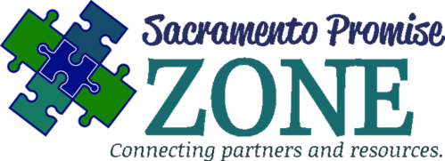
The value of being a part of the Promise Zone is the direct contact with a representative for a federal grant and the extensive network to help with the application for a federal grant. Moreover, the Promise Zone gives preference points for organizations in the Promise Zone so our partners can receive a competitive advantage over others to be awarded a federal grant. Property Business Improvement Districts (PBIDs) plays an integral part for business infrastructure and revitalization. When collectively working together, PBID’s and non-profits can apply to grants that can help with job creation, small business development, sustainable communities, and neighborhood revitalization throughout Sacramento.

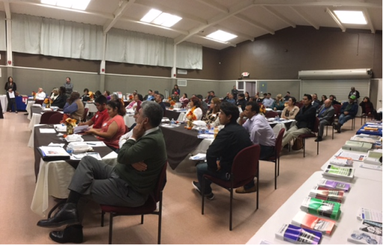
How can SHRA and PZ partners help PBID’s ?
California Capital Financial Development Corporation, the Promise Zone’s Lead Economic Development Implementation Partner, submitted an application for an Economic Development Administration Program Grant to facilitate small business forums to address the needs of businesses within Property Improvement Business Districts (PBIDs) in the Promise Zone, with attention paid to limited and non-English speaking business owners. These forums are just one way of helping to foster the development and growth of new and existing small businesses in Sacramento and the Promise Zone.
In the spring of 2016, California Capital Financial Development Corporation, Women’s Business Center Director, Deborah Lowe Muramoto, met with Malinda Matson from the Economic Development Administration to identify opportunities to fund programs that specifically address the needs of businesses in the Promise Zone. In October 2016, they were awarded an $80,000 grant to facilitate small business forums within PBID corridors in the Promise Zone. On November 1, 2016, California Capital held their Hispanic Bilingual Business Success Forum at La Familia Maple Neighborhood Center. As a result of their partnership with Rachel Rios, La Familia and Nathan Ulsh, North Franklin Business District Association and U.S. Bank, more than 100 business owners attended the Forum. Small business owners received a deeper understanding of permits, licensing, taxes, regulations, financial opportunities, and other resources to help understand how to start and grow their business.

How can collaboration among PBIDs in and out of the Promise Zone make a significant impact?
Forming collaborative partnerships to strengthen opportunities for federal grants such as the Economic Development Administration Assistance program is very beneficial for PBID’s to position themselves for Federal support. Joining with Promise Zone non-profit, government, and education partners can generate resources and services that fuel revitalization of neighborhoods and business corridors as well as improvements around economic development, infrastructure, sustainability, and health.

How can you stay informed?
Follow us and join our mailing list. For more information on grants and resources and to stay up to date on grants, then follow us!
www.SacramentoPromiseZone.org
Sacramento Promise Zone
- @SacPromiseZone
Email: awilfred@shra.org

